**Cumulative Sum in Data Flow**

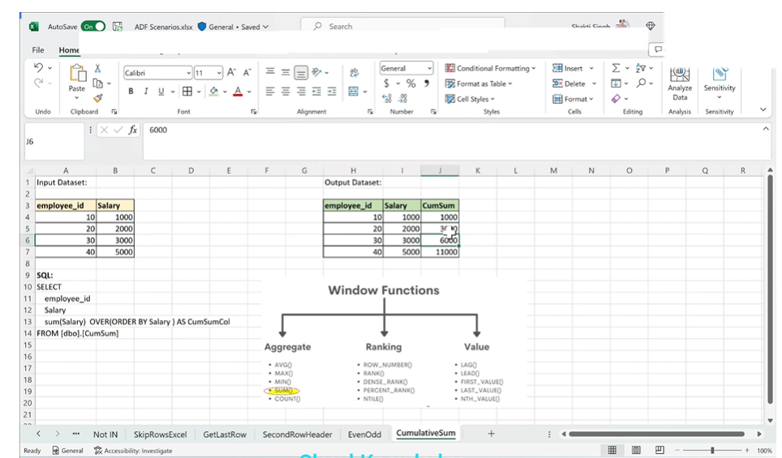

Under csv dataset need to add

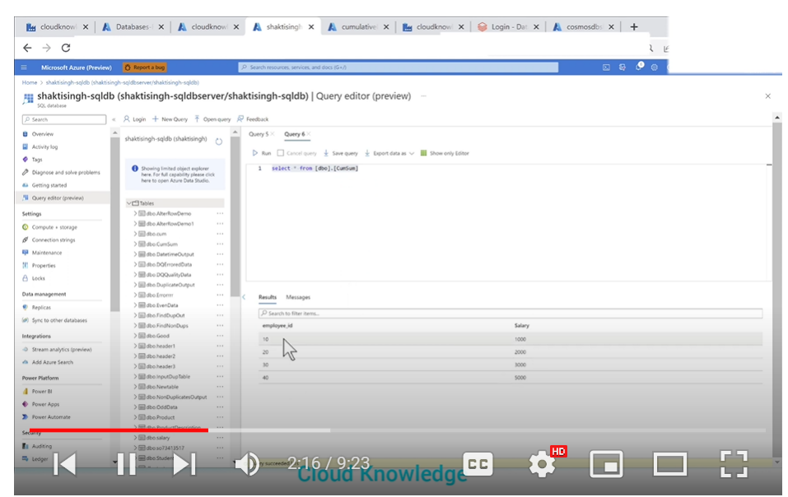



Create a pipeline called pipelinetocumsum









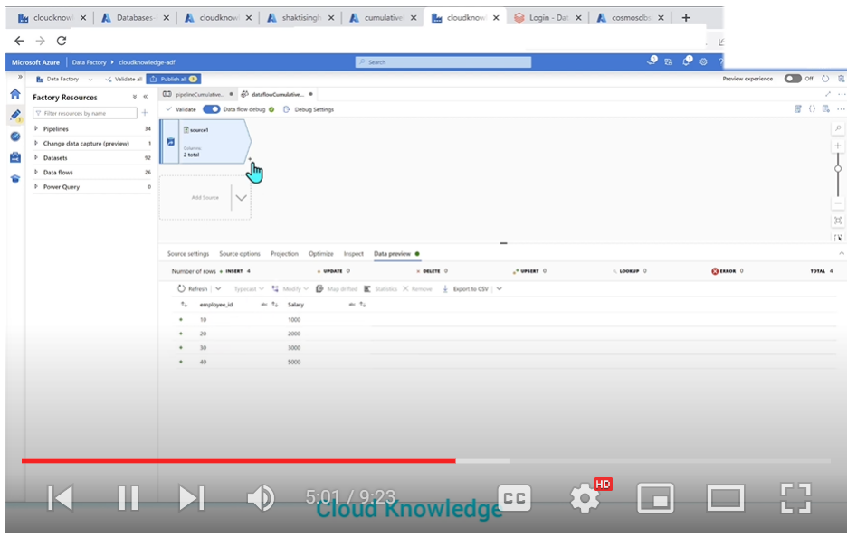

Now add derive column

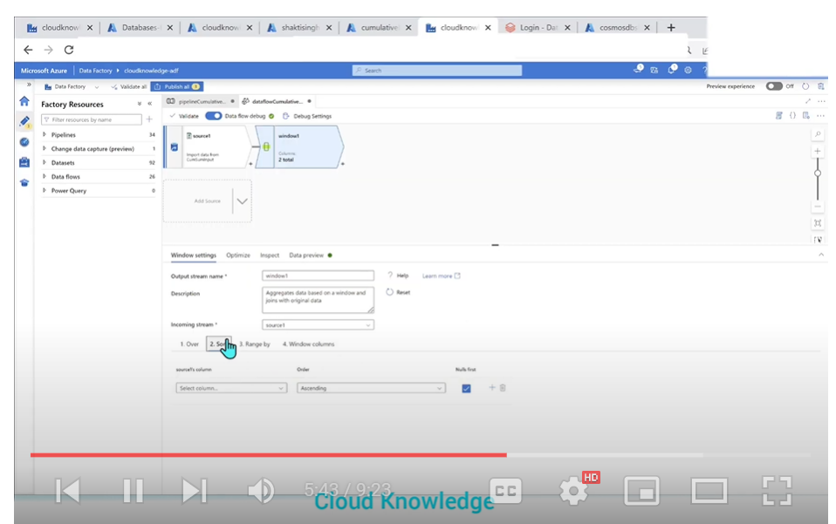

Under windows settings

Add 🡺 over as it is

Sort🡪 salary,ascending

Range by -🡪 as it is

Window column🡪 cumsum column name

Under expressin builder =🡺 sum(salary)

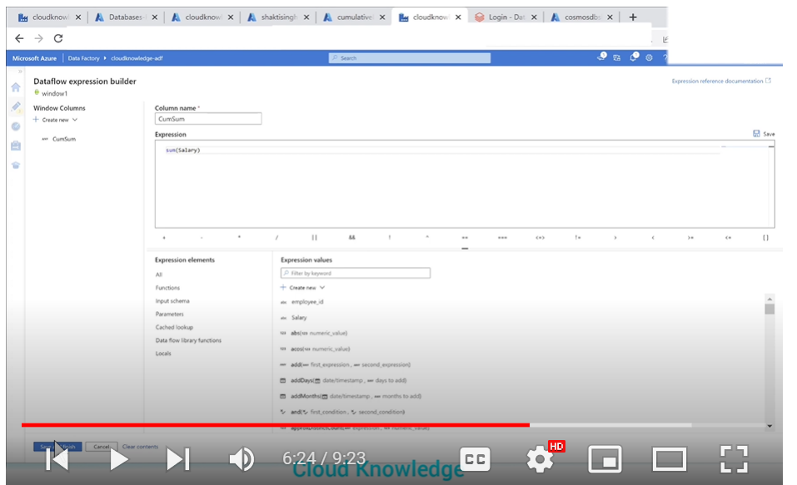

Now go to source

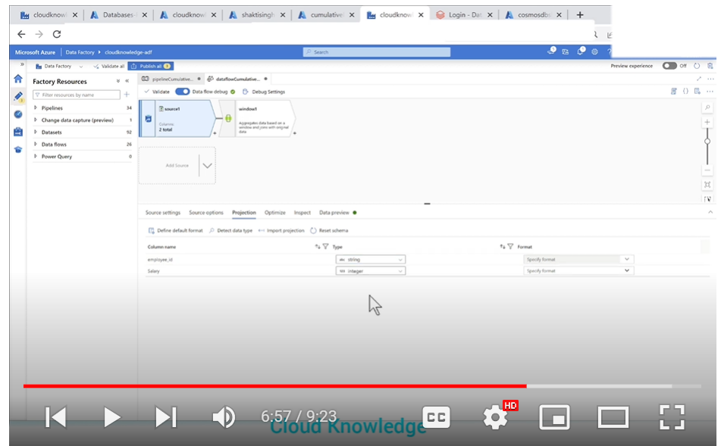

Projections=> make it as integers

now check data preview you will see output

now add sink

choose adlsgen2 as dataset

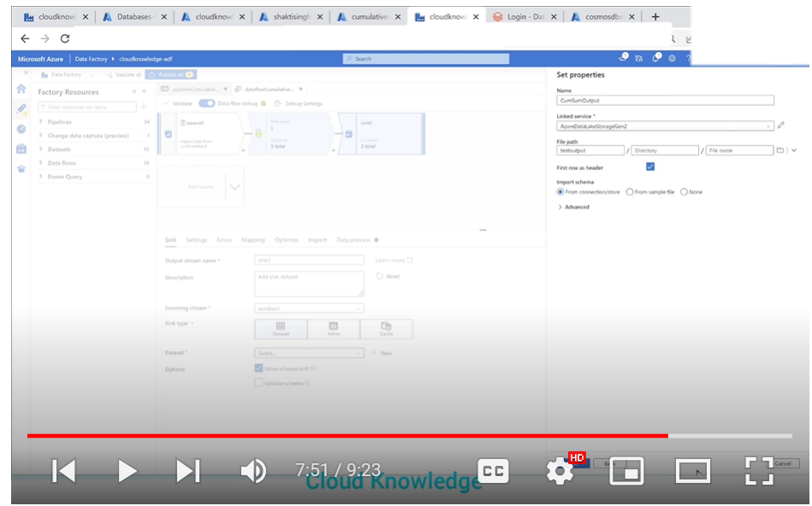

Under sink settinngs🡺 add outputtosinglefile

Cumsumoutput.csv as outputtosingle file option

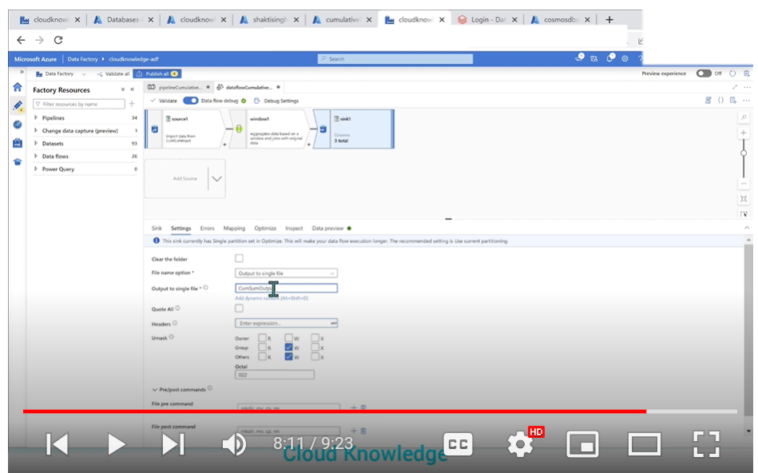

Now debug it

